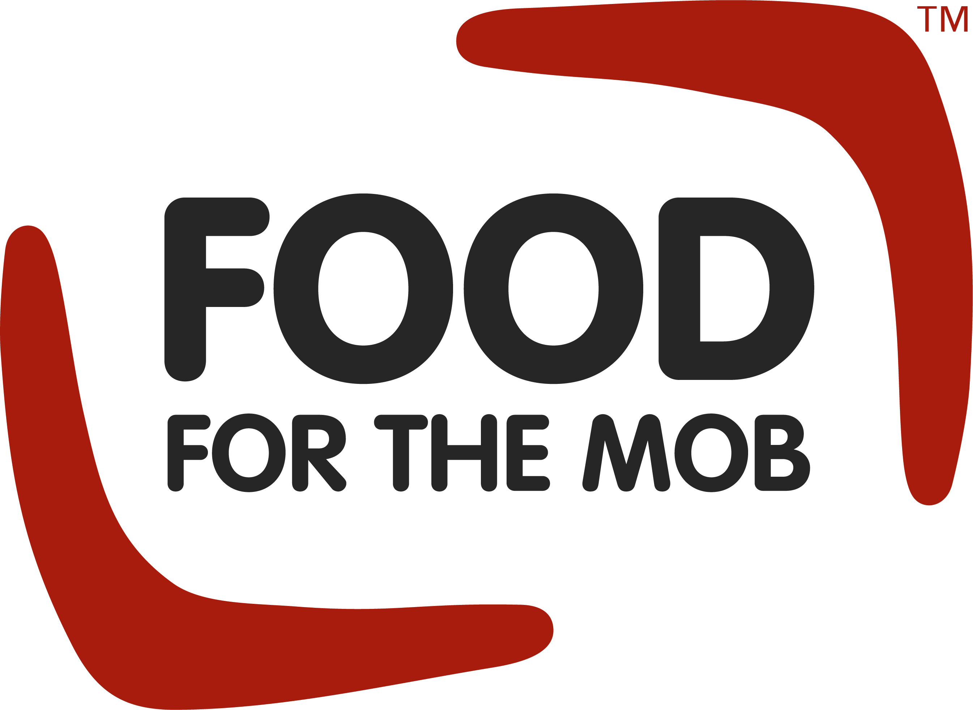
EMBARGOED ANNOUNCEMENT UNTIL
9AM AWST THURSDAY 11 JUNE 2020
On-Country Care to provide 26,000 free hot meals, healthcare and more to COVID-19 affected people in Gascoyne and Midwest.
In response to the COVID-19 pandemic restrictions across the Gascoyne and Midwest regions, the ABC (Aboriginal Biodiversity Conservation) Foundation Limited has collaborated with its community based partners and other organisations to implement an Emergency Relief Strategy: On-Country Care.
Prior to COVID-19, the West Australian Council of Social Services (WACOSS) used the development of a Food Stress Index to identify Carnarvon and Meekatharra as being areas of high food stress. However the pandemic has escalated these issues and Carnarvon and Meekatharra now feature as some of the most food stressed communities in WA.
Commencing in July 2020, On-Country Care will meet the needs of not only food insecurities, but healthcare and housing insecurities caused as a direct result of COVID-19, for the most vulnerable and high-risk members within the Gascoyne and Mid-West communities. People at risk include Aboriginal children, youth, elders and people with disabilities, as well as retirees in the Carnarvon and Meekatharra areas, small business owners related to travel and accommodation, and backpackers stranded in the Gascoyne region.
The ABCFL is well prepared to support these communities and contribute to On-Country Care not only through administration of the collaboration but more specifically with food relief through its Food for the Mob™ program. The program will deliver via On-Country Care, in addition to its regular services, 26,000 free hot meals over six months along with access to additional healthy, low cost and affordable meals. Food for the Mob™ is made possible through donations received by Foodbank and SecondBite.
The ability to further meet the needs of these communities is made possible through the collaboration of contributions between ABCFL and its community based partners: Bundiyarra Aboriginal Community Aboriginal Corporation, Mungullah Community Aboriginal Corporation and Yulella Aboriginal Corporation; along with Midwest Employment and Economic Development Aboriginal Corporation (MEEDAC) and Mission Australia. Enabling the capitalisation of each organisations strengths, the collaboration will provide clear messaging to communities and increase each organisations position to secure support for On-Country Care, as well as increase the strength of place-based and human resources, infrastructure and equipment to support the program.
Lotterywest has supported ABCFL with a $212,238 grant to fund the immediate needs of people experiencing financial hardship, reducing vulnerability and disadvantage in the Midwest and Gascoyne regions.

“What became clear to us at the Foundation during these unprecedented times, now more than ever, community based organisations need to work together to ensure vulnerable people and people becoming vulnerable as a direct result of COVID-19 are getting the support they need. When resources are in short supply, not working together only creates confusion and fosters resentment in the community” said ABCFL CEO Alison Sentance about the need for the collaboration between organisations.
On-Country Care will deliver free home pick-up and delivery services to those most vulnerable to access: medical prescriptions and general medical and healthcare needs; access to food and other essential services; and access to key personal appointments such as Centrelink appointments or counselling.
More information about the On-Country Care program will be available from July 2020.

The WA Government, through Lotterywest, supports community projects like On-Country Care, helping to build a better WA together.

For any media requests, please contact:
Kate Branson | Communications & Inclusion Officer
0406 611 619 | oncountry@abcau.com.au

