Preventing violence together
While the primary prevention of violence is still an emerging area of practice worldwide, it is generally agreed that it is possible to prevent violence against women and their children before it occurs. There is also mounting agreement that this problem is too prevalent and its consequences for both individuals and communities are too great to limit efforts to only responding after violence has occurred. Rather, there is a need to develop a spectrum of responses that ensure an adequate safety net exists for those already experiencing violence (crisis and support services), while also focusing deliberate and coordinated efforts on the prevention of violence before it occurs (primary prevention). This involves building on existing work with affected individuals and families to develop and incorporate strategies that support primary prevention.

It’s important that we make clear the connection between prevention and response work because they both address the issue of violence against women and their children, just at different stages. Prevention tackles the underlying causes of violence whereas response efforts address the impacts of violence after it occurs and aims to stop further violence from happening. Connection between the prevention and response sectors also means that all activities (and funding) are aligned towards a common goal – ending violence against women and their children.

It’s important to remember that primary prevention, early intervention and response are not rigid categories, but they can help us organise where our work sits along the continuum of efforts to end violence against women. For example, developing a workplace domestic and family violence policy is a response effort, because the main aim is to support someone after they have experienced violence. However, these policies can also have a preventative effect, as they can increase understanding amongst staff of the drivers of violence against women and the actions to challenge these.
Prevention activities also increase the likelihood of people disclosing that they have experienced violence. In order to do prevention work safely, it is essential to have a system in place that works to ensure victim/survivors get the support they need if they disclose. This involves making sure that the people leading prevention activities have the skills to provide a supportive first response and the connections necessary to refer people to specialist supports. It also means having appropriate organisational policies and processes to guide a best-practice response.
Stopping Family Violence, the Women’s Community Health Network and the Women’s Council for Domestic and Family Violence Services would like to map what primary prevention work is currently occurring in Western Australia so that we can better understand the WA primary prevention landscape. We would also like to better understand how we can support your primary prevention activities and help to share and promote this important work. To assist us with this mapping/needs analysis, we would appreciate it if you could please complete the following short questionnaire. For a description of primary prevention work please see page 3.

Please return the completed questionnaire to Alison Evans at email address: aevans@wchnwa.org.au

We would appreciate it if questionnaires were returned no later than October 2nd , 2020.

Questionnaire

Please complete as much or as little as you can. Even if activities are not currently ‘active’ it is useful to reference these in the responses.

- Organisation name and contact person for any follow up actions:

- Please provide the details of any domestic, family and sexual violence primary prevention work your organisation is currently involved in, including the target group/s, setting, geographical area:

- Are you happy for the above information and contact details to feature on a primary prevention website?

- Please state the beginning and end date of this primary prevention work (if ongoing please indicate when the work commenced):

- How is this primary prevention work resourced and is the initiative sustainable or one off/activity based/time limited?

- Have any of your primary prevention activities been evaluated? If so, are you happy to share the findings of the evaluation with the project team?

- What support/training would assist you with your primary prevention work (for example, training and professional development; resources, tools and guidance; access to communities of practice, networks, events and forums)?

- What topics would you be interested to learn about or explore more (for example, community awareness raising, promoting gender equity in your local community)?

- Would you be interested in presenting your primary prevention work at a 1-2 day conference focused on primary prevention evidence and practice (in 2021)?

Thank you for taking the time to complete this questionnaire!

Primary Prevention
or Prevention
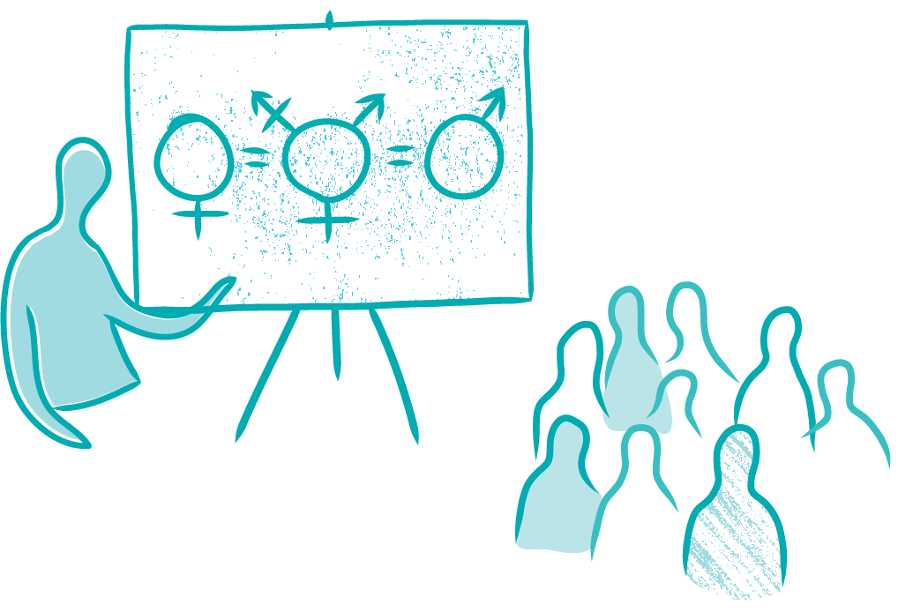
Working across communities, organisations and society as a whole in settings where people live, learn, work, socialise and play to stop violence from happening in the first place by challenging or addressing the things that drive violence against women.
If work in the domestic and family violence sector does not address one or more of the gendered drivers then it’s more likely to be early intervention or response work.

What can this work look like?
- Implementing whole school initiatives that promote gender equality and respectful relationships
- Working with the media to ensure that reporting on violence against women highlights the perpetrator’s responsibility rather than the victim’s behaviour or clothing
- Developing awareness-raising campaigns that make it clear that sexism and disrespecting women is never acceptable
- Delivering training about the gendered drivers of violence against women
- Running programs for first-time parents that unpack gendered roles and promote gender equitable parenting and household practices
- Supporting a local sports club to develop policies and procedures that ensure women and children have equal access to resources and appropriate facilities to support their participation in sport
- Implementing workplace initiatives that take a whole of organisation approach to addressing the gendered drivers of violence against women, including addressing issues such as sexual harassment in the workplace, unequal workplace policies, processes, leadership and workplace culture. This might include strategies such as establishing gender quotas for leadership positions, ensuring flexible working arrangements for all staff and delivering bystander training.

